Go to the Voter Registration Update page (https://voterservices.elections.maryland.gov/onlinevoterupdate/InstructionsStep1)

Follow the prompts and enter your info to reach this page, then click on “Update Mail-In Ballot Option”:

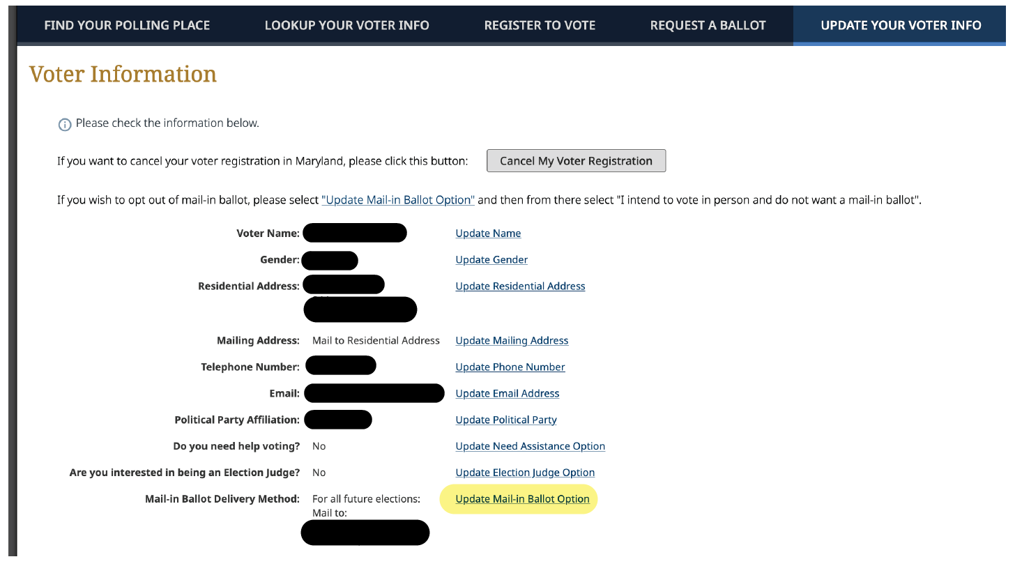

Click “I intend to vote in person and do not want a mail-in ballot”, then choose “Update Mail-In Ballot Option”:

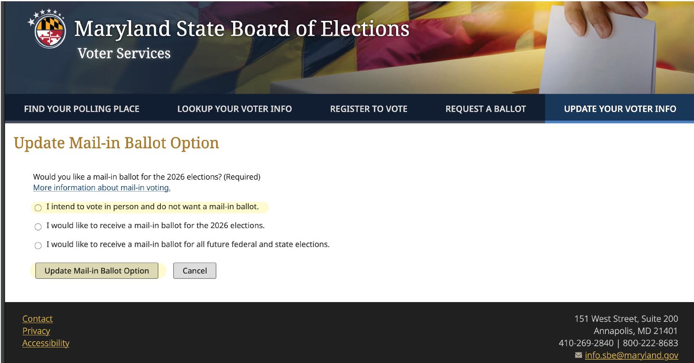

The next page will re-display your Voter Information
Confirm that you see “No Mail-in ballot requested”
Then choose “Make no change and exit”:

