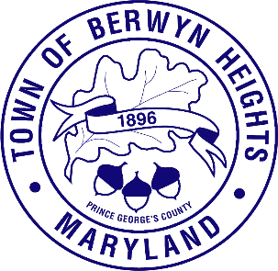

MAYOR

Tiffany Papanikolas

COUNCIL MEMBERS
Edgar Moctezuma (Mayor Pro Tem)
David Wolfinger
Roger Gaines
Chris Brittan-Powell

Town of Berwyn Heights

5700 Berwyn Road
Berwyn Heights, MD 20740
Tel. (301) 474-5000
Fax (301) 474-5002

Statement of Election Results

Nominees:
Chris Brittan-Powell 129
Zac Francis 163- Councilmember
Roger Gaines 199- Councilmember
Edgar Moctezuma 211- Mayor Pro Tem
Tiffany Papanikolas 283- Mayor
David Wolfinger 165- Councilmember

Certified Write In
Carlos Coral 88

Non-binding Ballot Question:
Should the Town explore ranked-choice voting for Berwyn Heights?
For 237 Against 73

