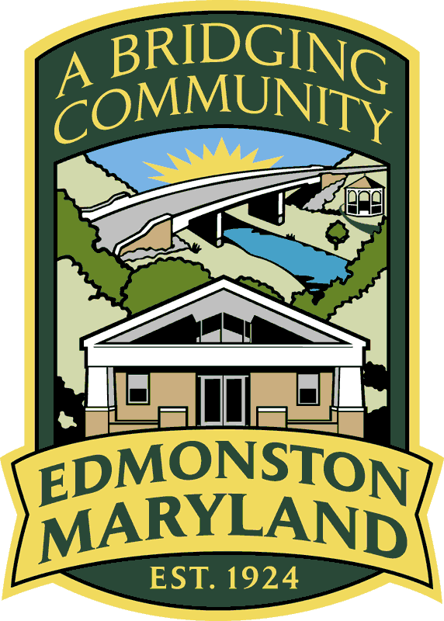
COUNCIL MEMBERS
MICHELLE BONILLA
BETSY MCCAULEY
JOHN A. JOHNSON
SARAH TURBERVILLE

MAYOR
TRACY R. GANT

TOWN ADMINISTRATOR
RODNEY BARNES

ADA-Accessible Text Version of the 2026 Edmonston Election Results
Image description (alt text): Town of Edmonston letterhead featuring the town seal and the tagline “A Bridging Community for Over 100 Years, 1924–2024.”

Title: Official Election Results — Town of Edmonston Election Date: Monday, May 4, 2026
Mayor – Townwide
- Julio Maltez:
  - Ward 1: 38 votes
  - Ward 2: 18 votes
  - Total: 56 votes

Council Member – Ward 1
- Michelle Bonilla: 30 votes
- Cameron Sherr: 26 votes

Council Member – Ward 2
- Walter Doyle: 14 votes
- Monique Burton: 13 votes
- John Johnson: 5 votes

Certification
These results were counted and verified by the Town of Edmonston Election Board on May 4, 2026, at 8:45 p.m., and notarized in Prince George’s County, Maryland.

Averi Gray
Town Clerk

