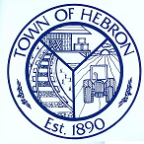
April 14, 2026

Wicomico County Board of Elections
345 Snow Hill Rd
PO Box 4091
Salisbury MD 21803-4091

Attention: Dionne Church, Election Director

The Election Judges for Town of Hebron Certified the Election on April 14, 2026, directly after the voting polls were closed.

The election results are as follows:

Kenneth W. Abrams – 34
Elizabeth K. Gravenor – 65
Jason D. Morris – 69
Mitchell L. Parks, Sr. – 15

Veronica Fox
Town Administrator
townadministrator@hebronmd.com
410-742-5555

Commissioners of Hebron, 100 N. Main Street, PO Box 299, Hebron, MD 21830
410-742-5555

